Forbes Travel Guide

7 New Rome Restaurants Worth Sampling

2017 9 MAR By Forbes Travel Guide Correspondent Erica Firpo

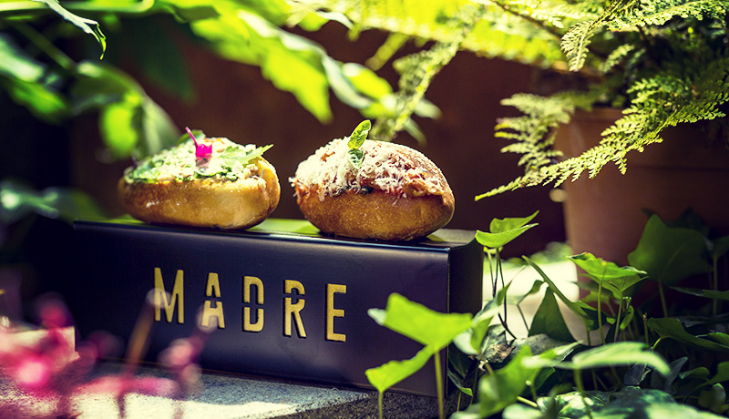
Chef Riccardo di Giacinto’s New Playground, Photo Credit: Madre
One thing is clear: You will never be hungry long in Rome. Almost every street has that typically charming spot with a pizza al taglio (pizza by the slice) rotation. Around each corner you’re likely to find pizzerie and trattorie. And eventually you’ll stumble across a produce market. You barely have to lift a finger or move your feet — it is really that easy to eat in the city.
Rome’s culinary scene is in the midst of a food adolescence, a gastronomic transition of limitless expression that sometimes plays around with tradition — or at least it tries to. And though the scene may still have some growing up to do, here are some not-to-miss newcomers for your little black book.
Secondo Tradizione Banco & Cucina
This tiny gastro-bistro in Rome’s Trionfale neighborhood, an out-of-the-way area that is worth the trip, has the feel of a Roman osteria from yesteryear. Chalkboard menus hang on the walls listing Secondo Tradizione’s fare. The I Classici list reveals the classics — the dishes that no honest Roman trattoria would be without, like carbonara and saltimbocca.
The Dal Banco (“from the counter”) board highlights the specialty cured meats and cheeses, while Dalla Cucina are the daily and seasonal creations from the kitchen and pans of chef Piero Drago. Drago came on board earlier this year, training under the wing of award-winning chef Anthony Genovese, who joined up with Secondo Tradizione to celebrate and innovate traditional cuisine, while keeping it simple.
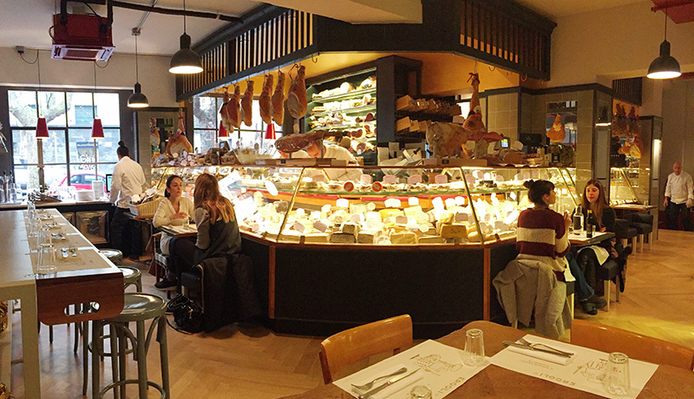
Ercoli 1928, Photo Credit: Erica Firpo
Ercoli 1928
Growing up means experimenting while looking back at tradition, so it’s no surprise that a contemporary crop of alimentari (“gourmet deli”) restaurants are open. Dual delicatessen/dining spot Ercoli 1928 in Parioli is both an over-the-counter food boutique showcasing a cornucopia of Roman and Italian delights — prosciutto, cheese, bread, caviar, wine and more — and a chic trattoria where chef Andrea di Raimo literally has the home-team advantage by masterfully using local and seasonal products in his recipes. Expect variations of Roman favorites, including a carbonara with fried artichokes.
La Tavola, Il Vino e La Dispensa
La Tavola, Il Vino e La Dispensa is the new baby of chefs Oliver Glowig and Salvatore de Gennaro. Located in the newly opened Mercato Centrale, a food stall opus in the 164-foot arched corridor of Rome’s Termini Station, La Dispensa turns the mezzanine terrace into a chic food bottega with counter and table service.
Like Secondo Tradizione, La Dispensa focuses on the gems of Italian regional cuisine and artisanal producers. Here you’ll find incredible cheese, delicious rosticini (tiny lamb skewers) or a rigatoni al bacalà (cod). Daytrippers should look out for the lunch menu for lighter fare, while the dinner menu is a little richer.
Madre
Down the road in the Monti neighoborhood, chef Riccardo di Giacinto gives you a little bit of motherly love with Madre, his version of fusion cuisine. Madre’s menu is a crazy and tasty mix of Roman fritti (fried foods) and ceviche. It’s hard to spot the traditional Roman influences until you taste the savory maritozzi, fried sweet buns filled with bollito e salsa verde (boiled beef in a parsley-based sauce). The garden restaurant is also a popular hangout for its cocktail scene.
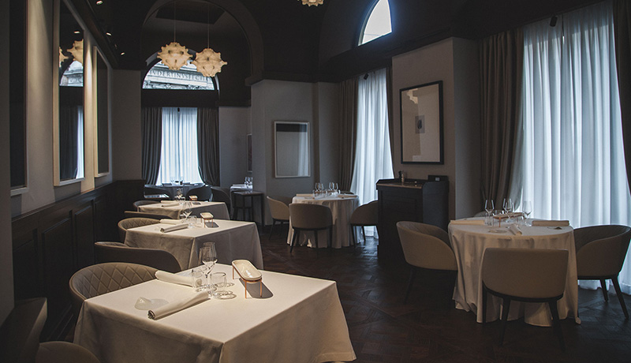
Pipero, Photo Credit: Pipero
Pipero
Pipero is the newest contribution from the fabulous carbonara master Luciano Monosilio and sommelier/restaurateur Alessandro Pipero. The duo first worked its magic at Pipero al Rex inside of Rome’s storied Hotel Rex. The newest spot, on Corso Vittorio Emanuele II, offers such varied courses as red shrimp risotto, T-bone steaks and a chocolate soufflé.
Retrobottega
Experimental kitchens are trending in Rome, and one of the best is Retrobottega, a closet-sized restaurant and self-proclaimed “gastronomic lab.” The overall style is rustic simplicity — in other words, a perfectly curated menu in a no-frills, counter-service setting.
A team of chefs creates daily specials in an open kitchen. The menu changes more than seasonally, so pop in for a quick read of its chalkboard list — you’ll find enticing spice combinations and savory game dishes.
Taverna Volpetti
Keep your eyes on Taverna Volpetti in Testaccio, a specialty food shop, wine bar and restaurant in the re-opened space. The menu offers charcuterie and cheese selections and delightful dishes like truffle tonnarelli. Round out your meal with a tipple from the impressive by-the-glass wine list.

