ERICA FIRPO

Blog/ a bit of buzz about Rome and Italy.
21 FEB 17

Ercoli, Ercoli! Prati’s new gastro hub
One of the reasons I love living in Rome is because life is all about the neighborhood. The mentality of Rome is that everything needed should be within a 500 meter radius. Here’s my mental neighborhood checklist anytime I move – outdoor produce market? Around the corner. Good butcher? Three within a four-minute walk. Alimentari? Maximum 5 minutes by foot. And the more one gets involved in the neighborhood, more amazing necessities can be found. My local black book book puts me on a first name basis with a magical cheese guy, an incredible tailor, a funny plumber, the entire Roscioli trifecta, my flower guy, gym and contact lens gal. And since this is Rome, I also get to enjoy a 2200-year-old archaeological site at my bus stop and a bizarre crypt on my bike path. Essentially, I have no need to ever get out but when the time calls, I love a good adventure. This time it’s Parioli and new neighborhood hub Errore. Riferimento a collegamento ipertestuale non valido..
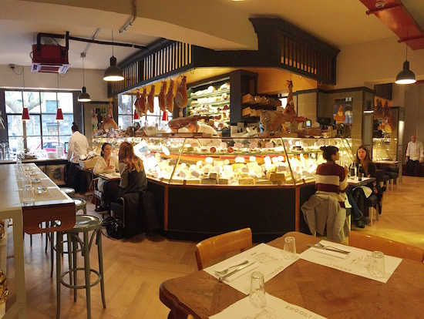
A hybrid delicatessen-restaurant, Ercoli is an intensely curated food specialties boutique that first and foremost offers counter service much like the local alimentari where my zio Romano gets due etti di prosciutto e un po’ di pane every single day. Note to the wise: a good alimentari is fundamental to any neighborhood- it becomes not just your food shop, but part of your daily social routine. You can be having an incredible crap day, and Luca, the guy behind the counter, will ask how you are and remember to slice your prosciutto incredibly thin, turning a bad day into better.
Counter service. Check. Ercoli’s huge wrap-around banco is an overstuffed cornucopia of Roman and Italian expectations and delights- prosciutto, cheese, bread, caviar, and more, that can be packed up up for porta via (to-go service) by the white-cloaked staff. I counted at least six white cloaks and chatted up two of them who will happily talk about lunch and dinner plans. For them, porta via also includes advice.
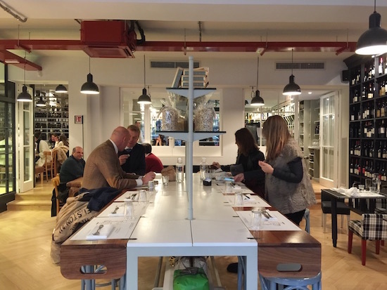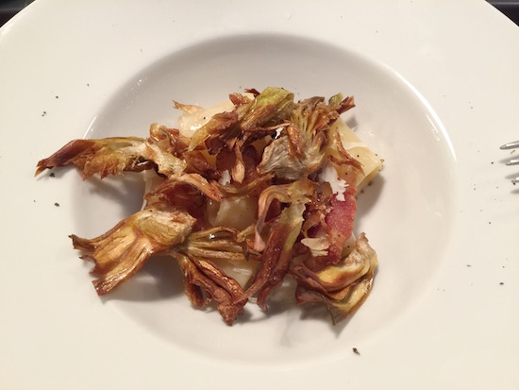
Turn away from the banco and you’ve walked into a restaurant – a Roman version of a gastro-bistrot- clean design with a “home” feel. Wall are lined with regionally organized bottles of wines (instead of books, but that’s better) and an each table is unique, creating an overall charmingly mismatched ensemble that is less hipster and more nonna chic. Chef Andrea di Raimo plays around with Roman recipes and literally has the home team advantage with all of the banco at his disposal along with seasonality. In other words, thanks to seasonality and di Raimo’s flare, expect variations of Roman favorites. So far, my favorite dish has been the carbonara (as above) with fried artichokes.
Did I mention the vermouth bar?
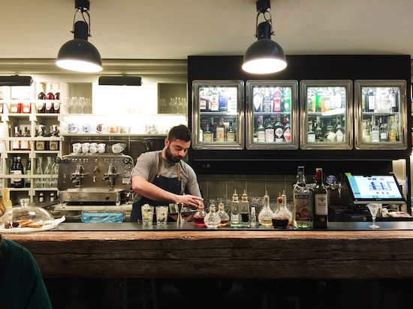
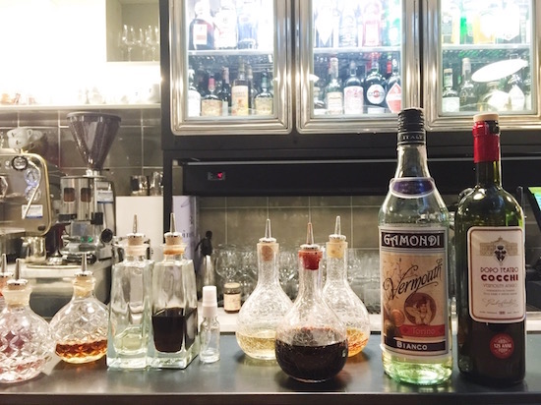
Head to the far back, and say hi to Federico Tomaselli, one of Rome’s original mixology revivalists. Standing over a huge wooden plinth, Federico has set up a delicious vermouth bar. As Fede says, vermouth is Italy’s signature drink, so it’s about time Rome celebrates it. His bar menu lists at least nine different Vermouth labels from the expected Martini e Rossi to Cocchi, Carpano and Mainardi, and each vermouth has at least two variants. 25 different vermouth cocktails make the menu, with several created specifically by Fede for Ercoli. And if you don’t like vermouth, it’s okay, the bar tome has classic cocktails, artisanal beers and bubbles, lots of bubbles.
Je sais, je sais, je sais what you are thinking. Ercoli isn’t anything new. Nope, the gastro-bistrot concept has been present in Rome for ages, but one is never enough. I personally love to see a great gastro-hub in every neighborhood. And technically, Ercoli is old news. The uber-gastro group helmed by Gino Cuminale and Dany Di Giuseppe acquired the original Ercoli, a Prati food institution (which was immortalized by artist Giacomo Balla in his 1942 La Fila per l’Agnello, a painting that is coincidentally found down the road in Parioli at La Galleria Nazionale) and decided not just to renovate the original Ercoli but to bring its little sister, or better yet, granddaughter to the Parioli scene. Great job, Ercoli.
Pro tip: take a walk around the newly-opened Balla exhibit at La Galleria Borghese, and then head to Ercoli for aperitivi and dinner.
Ercoli al 28
Viale Parioli, 184
06 8080084
From 9am to 2 am
